**Label Printing & Barcode Generator**

**Software Requirement Specification**

Version <1.0>

Prepared by

Nirali Sampat, Priyanshu Bhatnagar,

Rashika Bhargava, Simran Malhotra

Advanced Software

17th Sept 2016

Table of Contents

Revision History

1. Introduction
   1. Purpose
   2. Document Conventions
   3. Intended Audience and Reading Suggestions
   4. Product Scope
   5. References
2. Overall Description
   1. Product Perspective
   2. Product Functions
   3. User Classes and Characteristics
   4. Operating Environment
   5. Design and Implementation Constraints
   6. User Documentation
3. External Interface Requirements
   1. User Interfaces
   2. Hardware Interfaces
4. System Features
   1. Functional Requirements
5. Other Non-functional Requirements
6. System Quality Attributes

Revision History

|  |  |  |  |
| --- | --- | --- | --- |
| **Name** | **Date** | **Description** | **Version** |
| Label Printing & Barcode Generator SRS | 17th Sept 2016 | **SRS 1.0** | **<**1.0> |

* **Introduction**
  + **Purpose**

**The aim of this document is to give an overview of the Software Requirement Specification (SRS) with purpose, scope, conventions, references and overview of SRS. The goal is to gather and analyse and give the insight of Label Printing & Barcode Generator software. It also focuses on the capabilities required by stakeholders and the need of high level product features. It will also predict all sort of ideas which enable us to understand project. The concepts maybe altered or changed as the product develops.**

* + **Document Conventions**

**This document is divided into headings and sub headings; every sub heading is further given with a description about the product. The important parameters or features may be written in bold to have a better clarity in the SRS.**

* + **Intended Audience and Reading Suggestions**

**This document is for the developers, stakeholders and users who wants to understand, contribute or use our project. Developers pursuing Windows 10 Universal development platform can get a picture of how the software requirement specification of UWP is done. They will get to know more functions and capabilities of this platform.**

**Stakeholders and users who are going to use our product should know that our product is fulfilling their requirement. Our Intended Audience are from four Industries:**

1. **Textile Retailers/Wholesalers.**
2. **Food Retailers/Wholesalers.**
3. **Footwear Manufacturing Industries.**
4. **Universities/Schools for their examination purposes.**
5. **Personalised use.**
   * **Product Scope**

**Primarily, the scope of this product is to generate different type of labels. Labels are most commonly used among many organisations in order to keep organised their product/item and serialised. Our software targets many device families, like Laptops/Desktops, Mobile phones and Tablets. All these device families should be running with Windows 10 or above to support our product.**

* + **References**

[**https://www.google.co.in/url?sa=t&rct=j&q=&esrc=s&source=web&cd=1&cad=rja&uact=8&ved=0ahUKEwjU15SL35vPAhUFeD4KHaBXC-cQFggeMAA&url=https%3A%2F%2Fchannel9.msdn.com%2FSeries%2FWindows-10-development-for-absolute-beginners%2FUWP-001-Series-Introduction**](https://www.google.co.in/url?sa=t&rct=j&q=&esrc=s&source=web&cd=1&cad=rja&uact=8&ved=0ahUKEwjU15SL35vPAhUFeD4KHaBXC-cQFggeMAA&url=https%3A%2F%2Fchannel9.msdn.com%2FSeries%2FWindows-10-development-for-absolute-beginners%2FUWP-001-Series-Introduction)

[**https://www.google.co.in/url?sa=t&rct=j&q=&esrc=s&source=web&cd=1&cad=rja&uact=8&sqi=2&ved=0ahUKEwihn5Sa35vPAhWEjZQKHbI3A-QQFggcMAA&url=https%3A%2F%2Fmsdn.microsoft.com%2Fen-us%2Fwindows%2Fuwp%2Fget-started%2Funiversal-application-platform-guide&uh**](https://www.google.co.in/url?sa=t&rct=j&q=&esrc=s&source=web&cd=1&cad=rja&uact=8&sqi=2&ved=0ahUKEwihn5Sa35vPAhWEjZQKHbI3A-QQFggcMAA&url=https%3A%2F%2Fmsdn.microsoft.com%2Fen-us%2Fwindows%2Fuwp%2Fget-started%2Funiversal-application-platform-guide&u)

IEEE 830.docx

* **Overall Description**
  + **Product Perspective**

**This product is new, self-contained product. We are developing it for Advanced Software firm. It will be a simple system which will enable users to create a Label with Images and barcodes in an easy and faster way. It will be engaged with an external device like Wired/Wireless Printers. This product works on many family of devices running Windows 10 or above Operating System.**

* + **Product Functions**
* **Home Page**
  + **Four Categories**
    - **Textile Oriented Labels**
    - **Food Industry Oriented Labels**
    - **University/School Oriented Labels**
    - **Footwear Industry Oriented Labels**
* **Generate Label**
* **Add Rows and Columns of a Print Page.**
* **Can Add 7 Text Blocks in a Label with inputs.**
* **Set settings for each Text Blocks**
  + **Text Alignments**
  + **Width & Height**
  + **Font Alignment**
  + **Left, Top, Right, Bottom Margins**
* **Add Images**
  + **Width & Height**
  + **Image Alignment**
  + **Left, Top, Right, Bottom Margins**
* **Add Barcode**
  + **Width & Height**
  + **Barcode Alignment**
  + **Left, Top, Right, Bottom Margins**
* **Save and Print**
  + **Saving all the information in database**
  + **Moving forward for Printing**
* **Saved labels**
  + **Select Saved Labels**
  + **Move to Print**
* **Print Page**
  + **Preview Page**
  + **Select a Page**
  + **Print**

* + **User Classes and Characteristics**

**There will be four classes for users which they will be using frequently. Those classes will generate different templates of Labels and will be selected on Home Page of this software. These are as follows:**

* **Textile Label Template**
* **Food Label Template**
* **University/School Label Template**
* **Footwear Label Template**

**There is a use case diagram in order to understand all the actions involved in this software.**

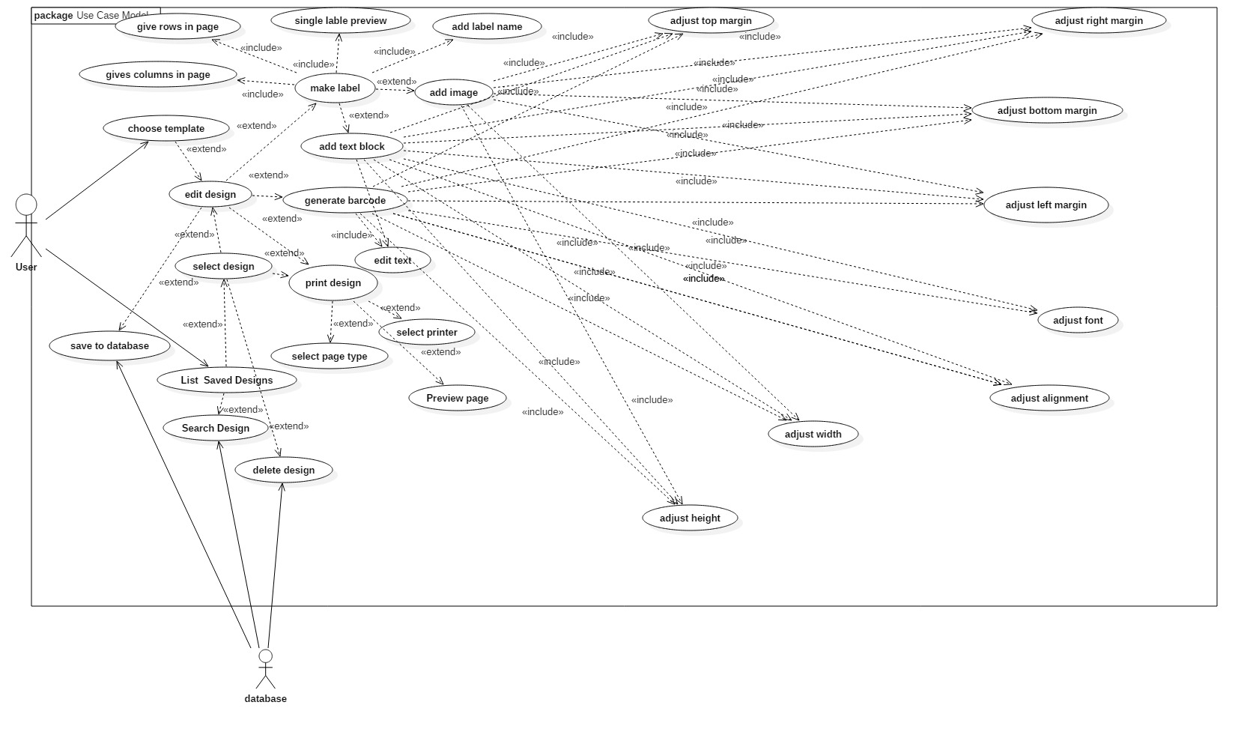

* + **Operating Environment**

**This software will run on any device which supports Windows 10 or above Platform. This software will be downloaded through Windows Store and will be installed in Encrypted area of operating system. All the user data is stored inside encrypted application data.**

* + **Design and Implementation Constraints**

**This software cannot occupy large amount of memory as it will be running on mobile phone which has low memory and as well as laptops/desktops which has large memory compared to mobile devices. Therefore, design and hardware limits will be more in this software compared to other typical native software exclusively design for laptops/desktops. All the data of users will be saved in a database and file management of application.**

* + **User Documentation**

**This software will be provided by detailed description of application. Software will be available on Windows Store which provides application owner to provide a detailed guide and video tutorials online. While downloading the application, users can read and go through everything.**

* **External Interface Requirements**
  + **User Interfaces**

When user will run the software he will get type of industries as four options. The user can choose any industry and make their respective labels. He can add multiple rows and can also delete them. User can set margin, add text. User will be able to customize labels according to his choice by adding images and barcode. Multiple images can be added. To add images, either user can browse the image or can drag and drop the image. Height, width and margin of image can be altered.

User can also add barcode. There will be an option for selecting the type of barcode i.e Numeric barcode or Simple barcode. After editing is completed, labels can be saved for future reference and finally labels are ready for printing. For printing software will provide the flexibility to use different kind of papers. As this software is portable, the whole process can also be done on tablets and phones based on Windows 10 platform.

* + **Hardware Interfaces**

Supported Device Types:

|  |  |  |
| --- | --- | --- |
| **Laptops** | **Tablets** | **Mobile Phones** |
| All laptops that have Windows 10 Operating System. | * Huwaei Windows 10 Tablets * Asus Windows 10 Tablets * HP Windows 10 Tablets * Lenovo Windows 10 Tablets * Lenovo Windows 10 Tablets * Microsoft Windows 10 Tablets * NuVision Windows 10 Tablets * Samsung Windows 10 Tablets * Toshiba Windows 10 Tablets | * Lumia 1520 * Lumia 930 * Lumia 830 * Lumia 735 * Lumia 730 * Lumia 640XL * Lumia 640 * Lumia 635 * Lumia 540 * Lumia 535 * Lumia 532 * Lumia 435 * Lumia 430 |

* **System Features**

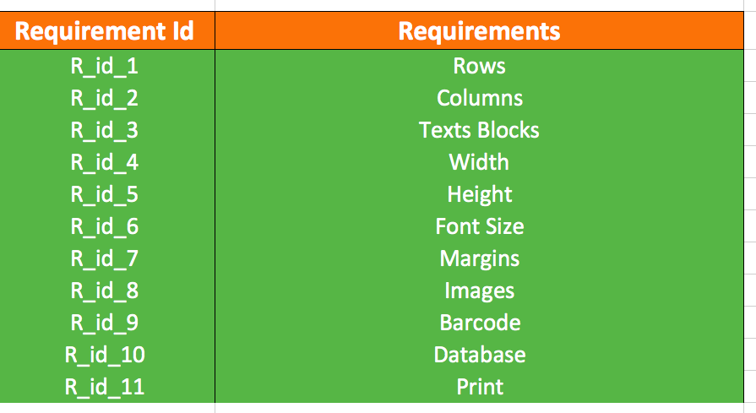

* **Other Non-functional Requirements**

These are the basic requirements to be completed in the software.

|  |  |  |
| --- | --- | --- |
| Requirement Number | Title | Description |
| 1. | Simple UI | A simple UI for easy interaction and understanding for the user. |
| 2. | Portability | The software should work on devices like PC, tablet and phone. |

# **System Quality attributes**

* + Portable
  + Reliable
  + Reusable
  + Robust
  + Correct
  + Maintainable
  + Compact